PHP and MySQL Data Visualization
by Joshua D Thomas
(Basic Implementation) – Optimized for Chrome Web Browser
Running on Apache Server w/ PHP, MySQL Server
January 1, 2026

XAMPP Control Panel Installed and Running
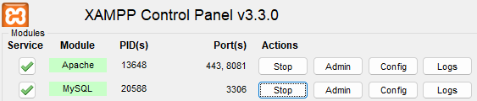

Integrating
Chart.js
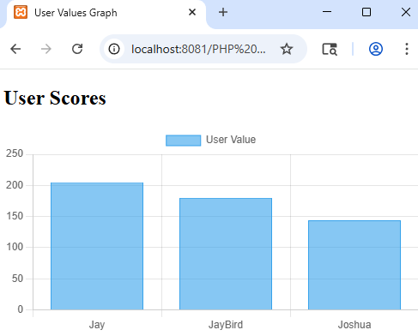
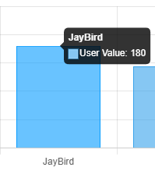
When hovering the Mouse, the actual value is Displayed in a pop-out bubble!
Tech Stack – Revisited
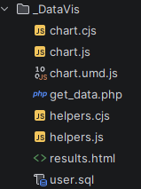

User.SQL is a Custom Database file containing columnar data: User Name, and User Value, which are displayed, graphically.

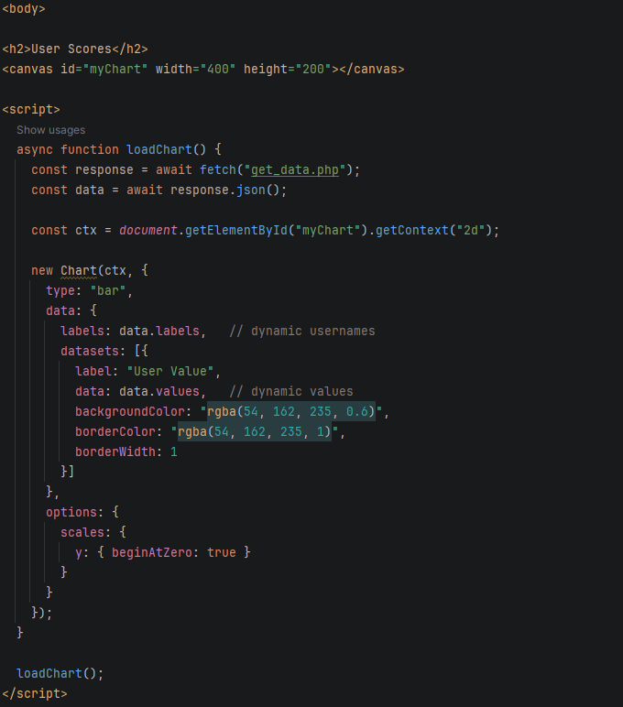
Front-End Code ABOVE.
PHP “Get Data” BELOW:

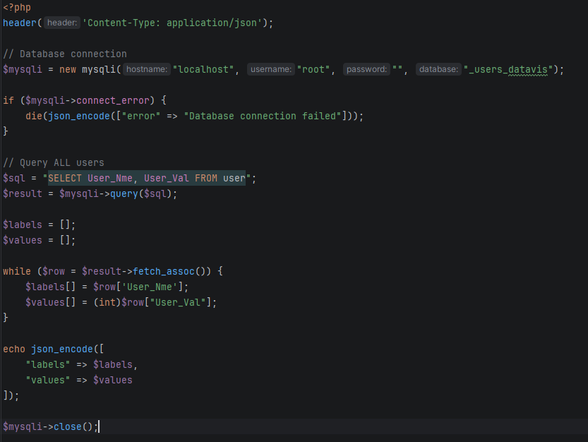
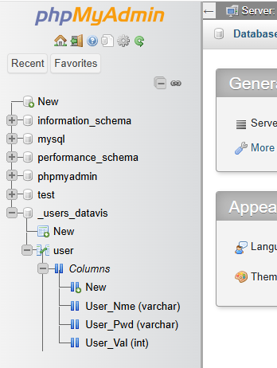

The End?

